**Customer journey:**

Over the past few years, advances in advertising technology in the areas of user interaction tracking and identity resolution have provided advertisers with a better-than-ever holistic view of their customers’ online interactions. The user interaction data available to marketers is richer than ever before, spanning both a vast timescale and a multitude of personal devices. Now, more than ever, advertisers can view the interaction of a specific customer with their brand over time as a chain of coherent and causally related events – rather than a single interaction on a single device. Insight into the customer journey – the sequence of advertising messages and customer actions that eventually lead to conversion – is key to understanding the customer, their current journey stage and potential next steps. Artificial Intelligence, alongside Zeta Global's massive Data Cloud, allows us to build sophisticated models of this customer journey.

Zeta Global tracks customers’ online interactions with our clients’ advertisements via third-party cookies. We store an expansive history of each customer’s interactions represented as a series of events -- such as display/mobile advertisements (impressions), clicks, website visits, opened emails, and conversions. Combining this proprietary data with our best-in-class identity resolution computational graph, we can assemble a step-by-step trace of each customer’s interactions with Zeta Global content, across all devices and marketing media.

Given this historical record of customer journeys, we can predict the next steps for current customers, assigning a probability to each step that we predict. This capability allows us to predict and prevent churn, ascertain which existing customers are likely to convert again soon, and determine optimal marketing strategies to acquire new converters.

## Use Case

Suppose a customer who is identified by cookie ID 123456789 has the following history of interactions with one of Zeta’s marketing clients:

We encode this series of interactions as a sequence of vectors which encapsulate the metadata about each event.  Our Customer Journey model accepts this sequence as input and indicates that the probable next steps are:

* conversion with probability 30%
* impression, followed by click with probability 45%
* additional website visit, with probability 25%

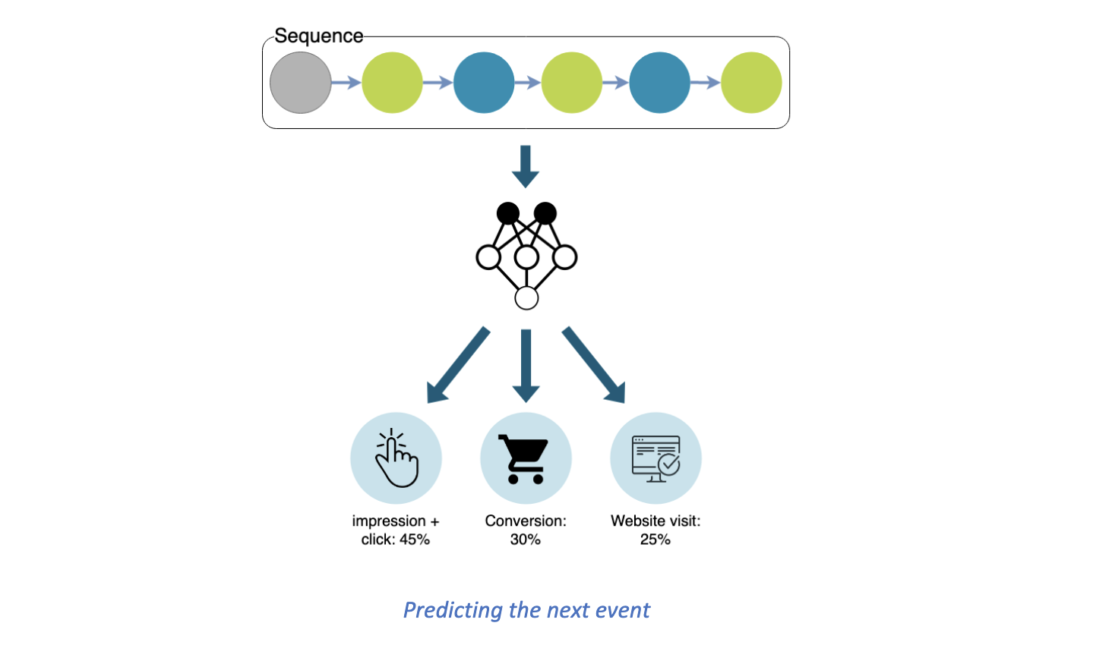

In addition to predicting conversion, churn, and other steps in the customer journey, we can also run a “what if” analysis by appending theoretical events to the existing sequence of events. For example, we can answer the question “How will the probability of conversion change if we send another marketing email?” by appending an “email” event to the existing customer journey and passing the augmented journey through the model again.

  Similarly, we can answer questions like “Would it be better to deliver an impression with creative A or creative B?”  We would augment the existing journey with an impression event using both creatives, pass each of the augmented journeys through the model, and check which results in a higher probability of conversion.

 Zeta’s powerful Customer Journey model enables marketers to analyze the most common paths to conversion, prevent churn, optimize messaging, and more!

## Long-Short Term Memory Sequence Modeling

We harness the power of Deep Learning to create unique and insightful customer journey models. By representing each journey as a sequence of events in time, we are able to leverage sequence-specific modeling techniques. These techniques improve the accuracy of future predictions by incorporating both information within and the order of a long history of prior events.